COAL LAB 6

ABDUL SAMI QASIM

22I-1725

CY-D

TASK1

CODE

.model small
.stack 100h
.data
arr db 5 dup(?)
msg1 db 10,13,"Enter 5 Numbers in Array:$"
msg2 db 10,13,"After Sorting Array:$"
.code
main proc
mov ax, @data
mov ds, ax

; Print "Enter 5 Numbers in Array:"
mov dx, offset msg1
mov ah, 09h
int 21h

mov cx, 5
lea bx, arr

inputs:
mov ah, 01h
int 21h
mov [bx], al
inc bx
loop inputs

mov cx, 5

OuterLoop:
mov bx, cx
xor si, si

CompLoop:
mov al, [arr+si]
mov dl, [arr+si-1]

cmp si, 0
je noSwap ; Jump if equal (si == 0)

cmp al, dl
jnc noSwap ; Jump if not carry (al >= dl)

xchg al, dl
mov [arr+si], al
mov [arr+si-1], dl

noSwap:
inc si
dec bx
jnz CompLoop

loop OuterLoop

; Print "After Sorting Array:"
mov dx, offset msg2
mov ah, 09h
int 21h

mov cx, 5
lea bx, arr

Outputs:
mov dl, [bx]
mov ah, 02h
int 21h
mov dl, ' '
int 21h
inc bx
loop Outputs

mov ah, 4ch
int 21h
main endp
end main

OUTPUT
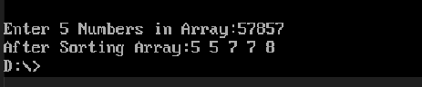

TASK2

CODE
.model small
.stack 100h
.data
arr db 1, 2, 3, 4, 5, 6, 7, 8, 9, 10, 11, 12, 13, 14, 15, 16, 17, 18, 19, 20
db 21, 22, 23, 24, 25, 26, 27, 28, 29, 30, 31, 32, 33, 34, 35, 36, 37, 38, 39, 40
db 41, 42, 43, 44, 45, 46, 47, 48, 49, 50, 51, 52, 53, 54, 55, 56, 57, 58, 59, 60
db 61, 62, 63, 64, 65, 66, 67, 68, 69, 70, 71, 72, 73, 74, 75, 76, 77, 78, 79, 80
db 81, 82, 83, 84, 85, 86, 87, 88, 89, 90, 91, 92, 93, 94, 95, 96, 97, 98, 99, 100
msg db 10, 13, "Odd Numbers from 1 to 100: $"
.code
main proc
mov ax, @data
mov ds, ax

mov cx, 100 ; Number of elements in the array
lea si, arr ; Load the address of the array into SI
mov bx, 1 ; Starting number to check

findOdds:
mov ax, bx
and ax, 1 ; Check the least significant bit of AX
cmp ax, 1 ; Compare with 1 to check if odd
jne notOdd ; Jump if not equal (even number)

mov [si], bl ; Store the odd number in the array
inc si ; Increment the array index

notOdd:
inc bx ; Increment the number
loop findOdds

; Print "Odd Numbers from 1 to 100:"
mov dx, offset msg
mov ah, 09h
int 21h

mov cx, 100 ; Number of elements in the array
mov si, offset arr ; Load the offset of the array into SI

printLoop:
mov dl, [si] ; Load the current element from the array into DL
add dl, 30h ; Convert the number to ASCII character
mov ah, 02h ; Function to print character
int 21h ; Print the character

inc si ; Increment the array index
loop printLoop

mov ah, 4ch ; Exit program
int 21h
main endp
end main

OUTPUT
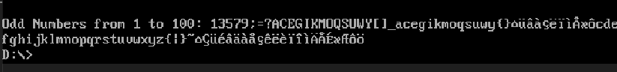

TASK3

CODE
.model small
.stack 100h
.data
arr db 1, 1, 3, 1, 5, 6, 7, 1, 9, 0 ; Array of 10 elements
num1 db ?
num2 db ?
result db 10 dup('$') ; Variable to store the result
msg1 db 10,13,"num1: $"
msg2 db 10,13,"num2: $"
foundMsg db 10,13,"FOUND$"
notFoundMsg db 10,13,"NOT FOUND$"
.code
main proc
mov ax, @data
mov ds, ax

; Take input for num1
mov dx, offset msg1
mov ah, 09h
int 21h
mov ah, 01h ; Function to read character
int 21h ; Read character from standard input
sub al, '0' ; Convert ASCII to binary
mov num1, al

mov cx, 10 ; Number of elements in the array
lea si, arr ; Load the address of the array into SI
mov bl, num1 ; Load num2 into BL
checkNum1:
cmp bl, [si] ; Compare current element with num1
je num1Found ; Jump if equal (num1 is found)
inc si ; Increment the array index
loop checkNum1

mov dx, offset notFoundMsg ; Load the offset of "NOT FOUND" message into DX
mov ah, 09h ; Function to print string
int 21h
jmp input2

num1Found:
mov dx, offset foundMsg ; Load the offset of "FOUND" message into DX
mov ah, 09h ; Function to print string
int 21h

; Take input for num2
input2:
mov dx, offset msg2
mov ah, 09h
int 21h
mov ah, 01h ; Function to read character
int 21h ; Read character from standard input
sub al, 30h ; Convert ASCII to binary
mov num2, al

; Check if num2 is in the array
mov cx, 10 ; Number of elements in the array
lea si, arr ; Load the address of the array into SI
xor bl,bl
mov bl, num2 ; Load num2 into BL

checkNum2:
cmp bl, [si] ; Compare current element with num2
je num2Found ; Jump if equal (num2 is found)
inc si ; Increment the array index
loop checkNum2

; If execution reaches here, both numbers are not found
mov dx, offset notFoundMsg ; Load the offset of "NOT FOUND" message into DX
mov ah, 09h ; Function to print string
int 21h
jmp endProgram

num2Found:
mov dx, offset foundMsg ; Load the offset of "FOUND" message into DX
mov ah, 09h ; Function to print string
int 21h

endProgram:
mov ah, 4ch ; Exit program
int 21h
main endp
end main

OUTPUT
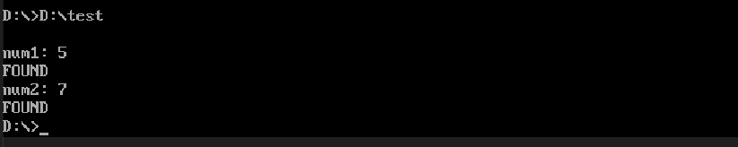

TASK4
CODE
.model small
.stack 100h
.data
num1 db ?
num2 db ?
msg1 db 10,13,"num1: $"
msg2 db 10,13,"num2: $"
bigmsg db 10,13,"larger number: $"
.code
main proc
mov ax, @data
mov ds, ax

; Take input for num1
mov dx, offset msg1
mov ah, 09h
int 21h
mov ah, 01h ; Function to read character
int 21h ; Read character from standard input
sub al, '0' ; Convert ASCII to binary
mov num1, al

mov dx, offset msg2
mov ah, 09h
int 21h
mov ah, 01h ; Function to read character
int 21h ; Read character from standard input
sub al, '0' ; Convert ASCII to binary
mov num2, al

mov al, num1
cmp al, num2
jbe secondnum

mov dx, offset bigmsg
mov ah, 09h
int 21h
mov al, num1
add al, '0'
mov dl, al
mov ah, 02h
int 21h

jmp endProgram

secondnum:
mov dx, offset bigmsg
mov ah, 09h
int 21h
mov al, num2
add al, '0'
mov dl, al
mov ah, 02h
int 21h

endProgram:
mov ah, 4ch ; Exit program
int 21h
main endp
end main

OUTPUT
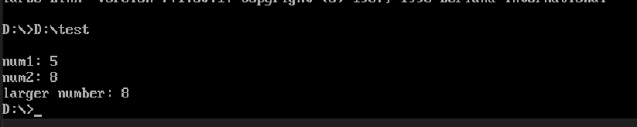

TASK5

CODE
.model small
.stack 100h
.data
arr db 5 dup(?)
msg1 db 10,13,"Enter 5 Numbers in Array:$"
msg2 db 10,13,"After Sorting Array:$"
msg3 db 10,13,"Smallest Number: $"
msg4 db 10,13,"Largest Number: $"
.code
main proc
mov ax, @data
mov ds, ax

; Print "Enter 5 Numbers in Array:"
mov dx, offset msg1
mov ah, 09h
int 21h

mov cx, 5
lea bx, arr

inputs:
mov ah, 01h
int 21h
mov [bx], al
inc bx
loop inputs

mov cx, 5

OuterLoop:
mov bx, cx
xor si, si

CompLoop:
mov al, [arr+si]
mov dl, [arr+si-1]

cmp si, 0
je noSwap ; Jump if equal (si == 0)

cmp al, dl
jnc noSwap ; Jump if not carry (al >= dl)

xchg al, dl
mov [arr+si], al
mov [arr+si-1], dl

noSwap:
inc si
dec bx
jnz CompLoop

loop OuterLoop

mov dx, offset msg3
mov ah, 09h
int 21h

mov dl, arr
mov ah, 02h
int 21h

mov dx, offset msg4
mov ah, 09h
int 21h

mov dl, arr+4
mov ah, 02h
int 21h

mov ah, 4ch
int 21h
main endp
end main

OUTPUT
